

X-DISP

SteelPumps Status Display Panel

Installation and Operation Manual

Table of Contents
Description Of Operation 2
Installation 2
Safety Precautions 2
Included Components 3
Layout 3
Control Panel Mounting 3
Connections 4
Operation 6
Safety Precautions 6
Usage 7
Specifications 7

Description Of Operation

The X-DISP Display Panel provides a remote display facility for all automatic SteelPumps models, indicating the presence of a power supply to the pump, and the activation status of the pump (whether the pump is idle or pumping water).

The visual indication of power supply to the pump provides (the green light) alerts the user to a tripped power supply, failure of backup power, or wiring fault.

The Active light (amber) indicates the frequency of pump startups, failure to start, or continuous running, alerting the user to problems which may otherwise cause premature pump failure.

Installation

Safety Precautions
Mains Voltage – There are exposed electrical conductors inside this appliance. This appliance must be installed and serviced by a competent electrical technician to the current requirements of BS7671 and IEEE recommendations. Before servicing this appliance, normal safe isolation procedures should be implemented.

Do not touch any connection terminals while energised.

Do not attempt to service this item when wet, or in a wet or high humidity environment.

If the housing of the control panel becomes damaged, you must shut down and securely isolate this appliance immediately.

Included Components
X-DISP Series Control Panel
Attached mains cable
Installation & Operation Manual

Also Required – 4 core flex to supply power to the pump and carry the return signal to the panel.

Layout
The control panel cannot be mounted outside, it is not fully weather resistant, but can be installed in sheltered outdoor locations (barns, covered areas, etc).

Voltage drop will affect the cable size needed to take power to your appliances. The more current is drawn the greater the effect over distance. Over very long runs, you may find it more economical to install contactors near to the pumps, allowing you to control the pumps with a sensible cable size. It is strongly recommended that you calculate voltage drop for cable runs which exceed the length of cable supplied with the pump. Failure to do so may result in cable overheating, conductor migration, and risk of fire.

Suitable circuit protection must be installed and should include as a minimum a suitable earth, overcurrent protection, and residual current protection at 30mA, ideally on it's own circuit, but always in accordance with BS7671 and applicable regulations.

Control Panel Mounting
Open the cover of the control panel. There are 4 recesses, one on each corner of the panel. Drill through at these locations and attach to the wall or a suitable support, taking care not to damage cabling inside the panel. Fixings are not included and should be selected to suit the material to which the panel will be mounted.

Connections

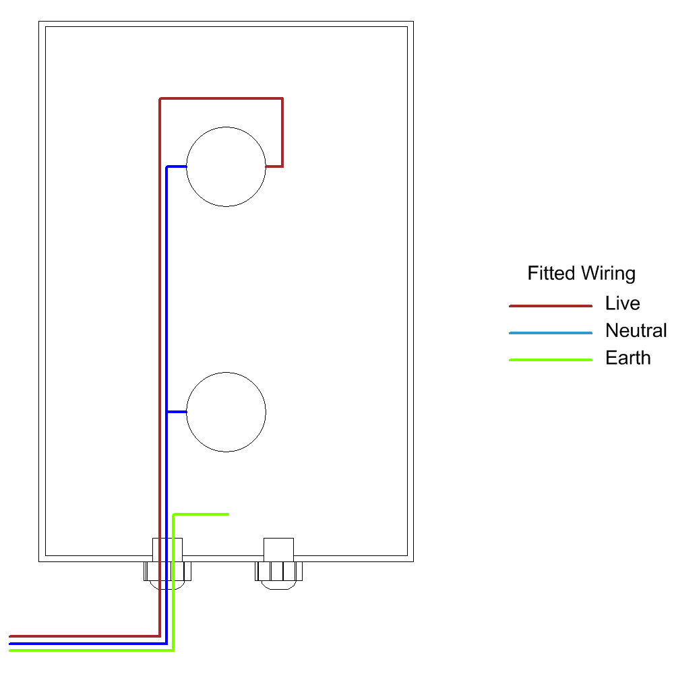

The control panel is supplied with wiring installed in the drawing shown above. The 4 core flex needs to be fitted as shown in the next diagram.

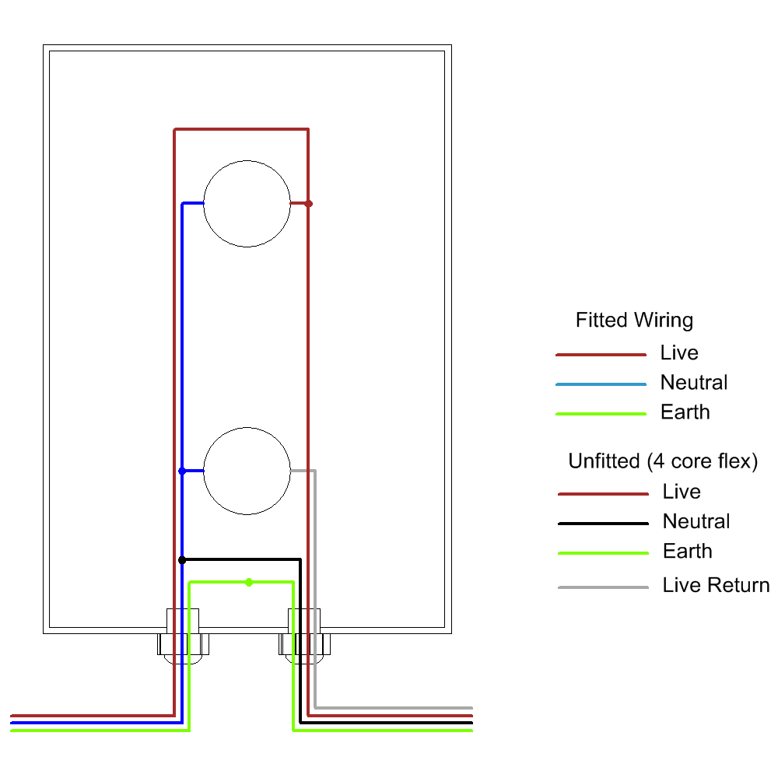
Note that 4 core flex contains different conductor colours to the European Harmonised Wiring colours normally used for single phase appliances. You may wish to mark cable ends with harmonised colours or attach warning notices to cabling and junction boxes as required by current regulations.

The neutral conductor to the pump is coloured black, and the live signal from the pump back to the control panel is coloured grey.

Wiring within the SteelPump is shown in the following diagram. The original mains flex is removed entirely and replaced with the new 4 core flex.
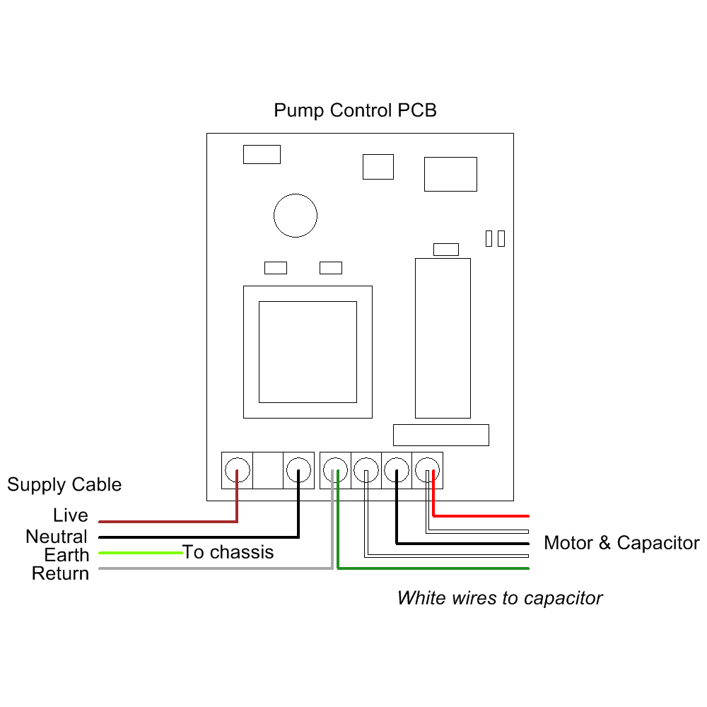
Note the additional connection to the 3rd terminal where the new grey wire joins with the existing green motor wire. This is the common phase to the motor and is energised each time the motor is active.

Operation

Safety Precautions
Mains Voltage – There are exposed electrical conductors inside this appliance. Before servicing this appliance, normal safe isolation procedures should be implemented.

Do not attempt to operate this item when wet, or in a wet or high humidity environment.

If the housing of the control panel or attached wiring becomes damaged, you must shut down and securely isolate this appliance immediately.

Usage

Once energised the display panel will show a green light. This light is constantly energised as long as there is power to the pump system. It indicates that the system is ready to operate automatically as and when required, and that there has been no disconnection or trip of any circuit breaker.
If the green light goes out, check the circuit breaker at the consumer unit supplying this circuit. Reset if necessary. If the circuit trips again do not reset but instead have the system checked by an electrically qualified service agent or a qualified electrician.
The amber light shows that the pump is currently operating and pumping water. Under normal conditions the pump will switch on when there is a demand for water and stay on as long as the outlet or appliance continues to draw water.
Restarts should not generally occur when there is no demand for water except for very occasionally. Frequent restarts for no apparent reason should be investigated, as they may indicate a leak. Leaks will reduce the useful life of the pump and consume electricity, if the leak is in the pump discharge connections within a water tank in which the pump is situated, repeated recycling of the same water will occur and may lead to excessive heating and damage.
Leaks may also occur in float valves (ballcocks) in toilet cisterns and header tanks.
If you feel a pump is restarting too often and no cause can be found, a pressure vessel installed on the discharge line will reduce the frequency of start-ups dramatically, as well as reducing overall run time and power consumption.

Specifications
Dimensions 180mm x 110mm x 90mm
Enclosure Material Polystyrene
Ingress Protection IP66
Electrical Protection Class 2
Voltage 230VAC 1~

